HOME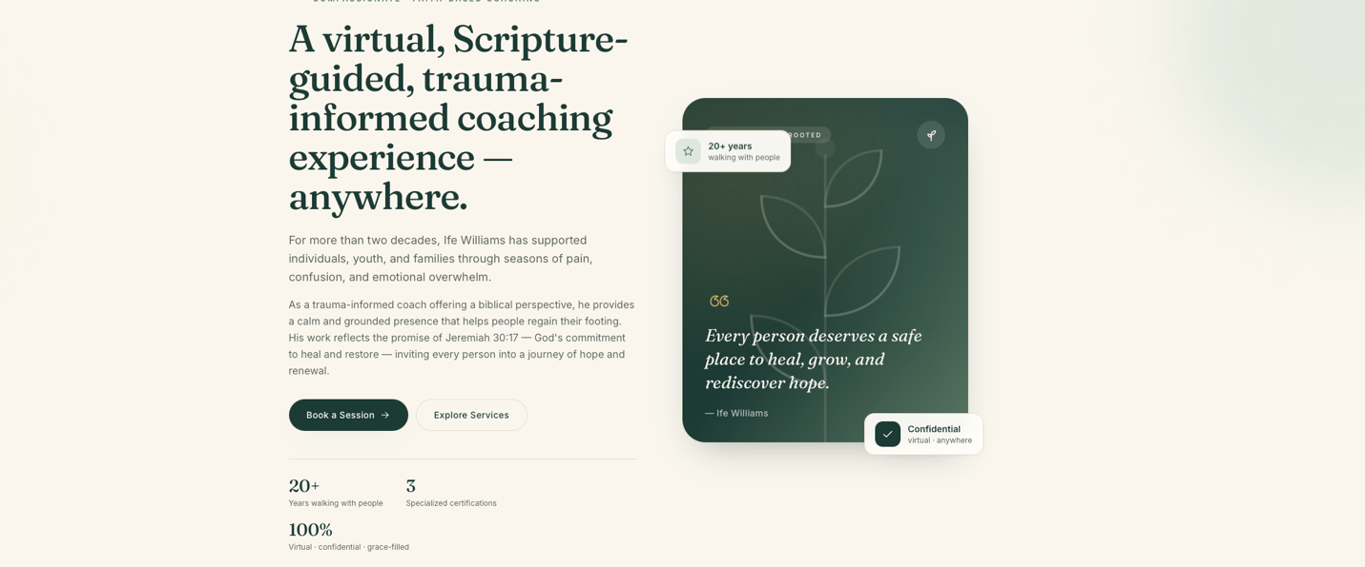
Replace picture with -
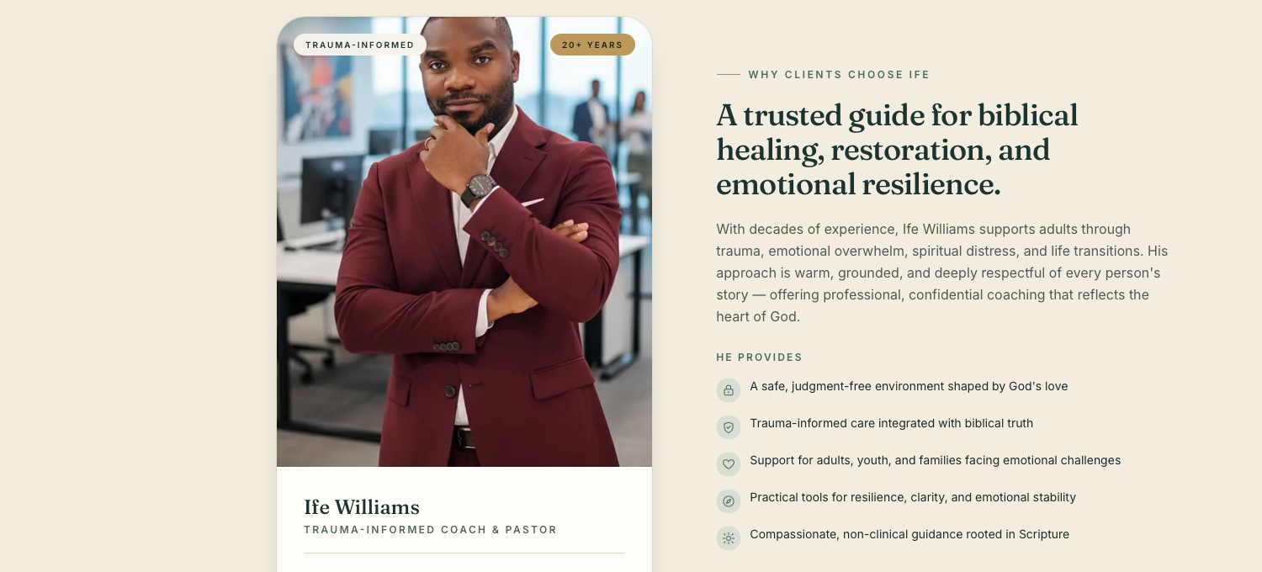
- Replace Picture - https://drive.google.com/file/d/1xwhOJuP13sIYLLg66iXHKrT2rwRdsR_4/view?usp=share_link

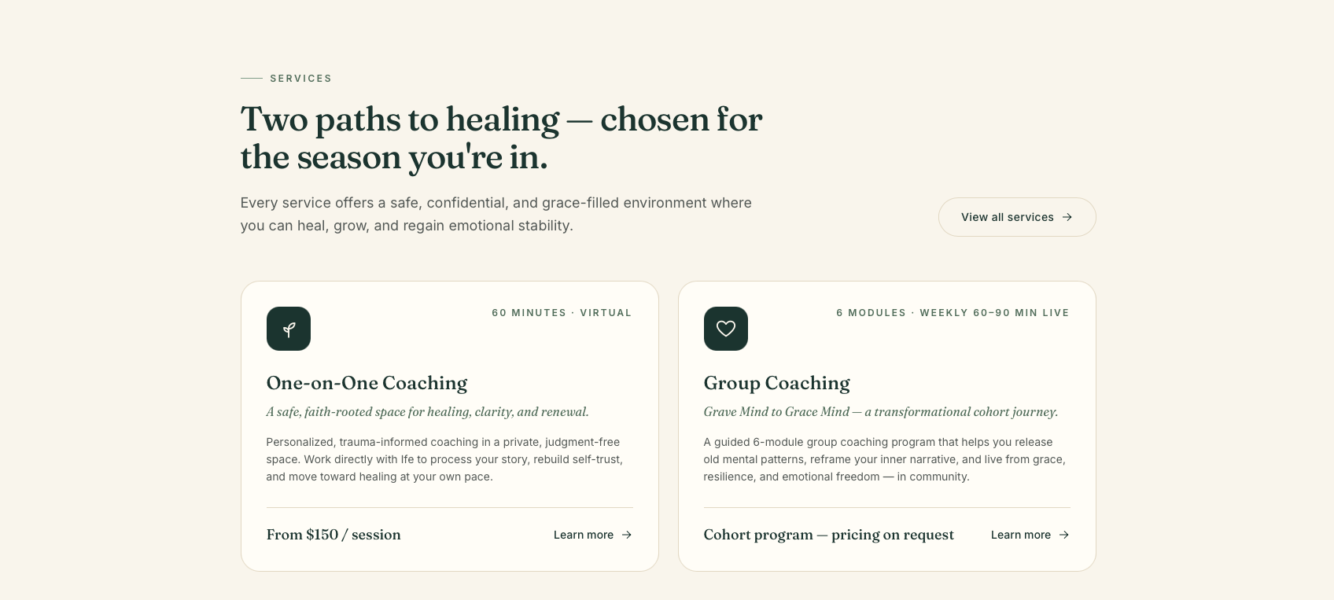
- Add this picture for 1:1 - https://drive.google.com/file/d/16iRoDlEmCt2kio6l31PGcJzAQo-i_5kP/view?usp=share_link
- Add this picture for Group
https://drive.google.com/file/d/1gumFaVoOLNzdDZ4wZZ53ycTLShOP4Hvj/view?usp=share_link

ABOUT PAGE
- Add picture https://drive.google.com/file/d/1gumFaVoOLNzdDZ4wZZ53ycTLShOP4Hvj/view?usp=share_link
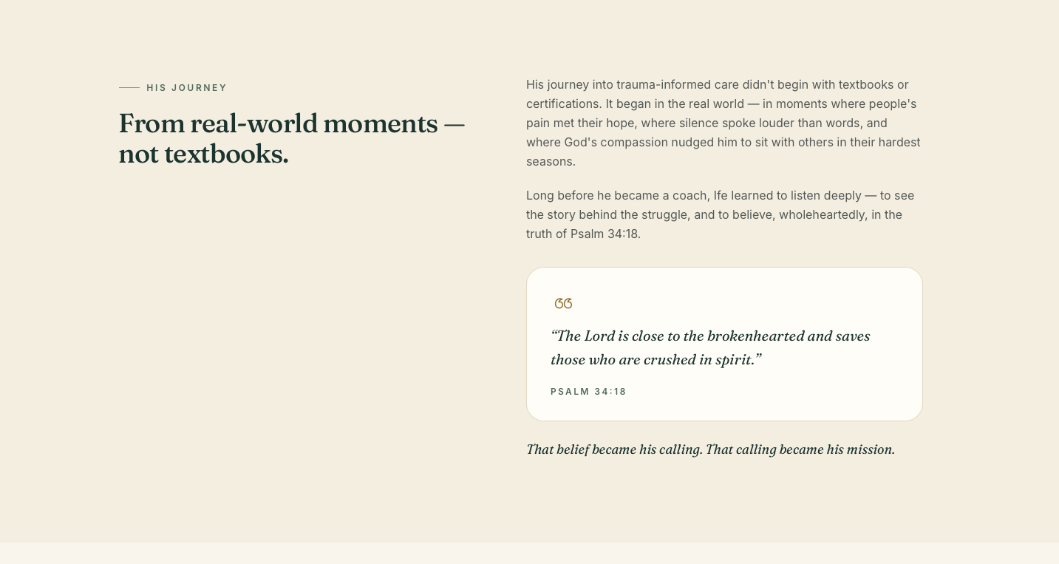

- Add this picture here
https://drive.google.com/file/d/12EUz6bkPhNhoaDbsVuIgsAXRVe9372D7/view?usp=share_link
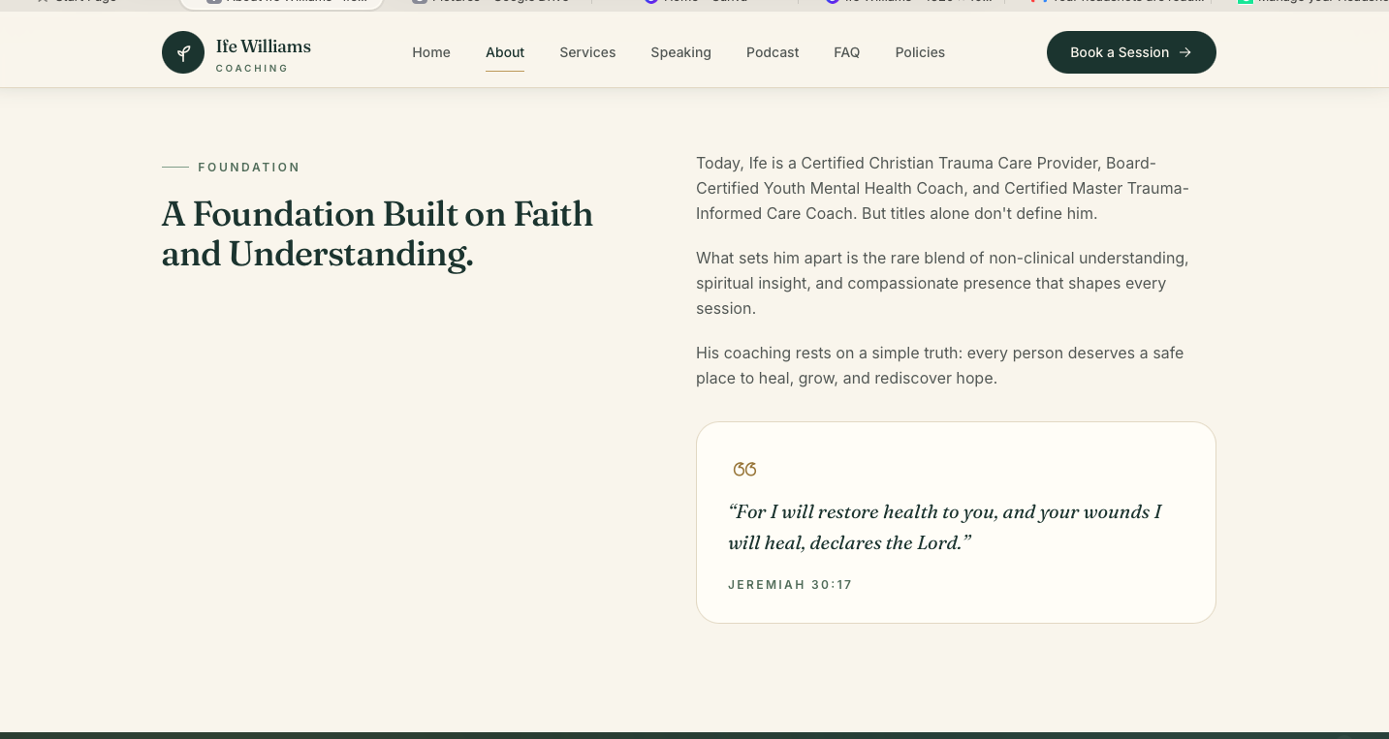

SERVICES PAGE
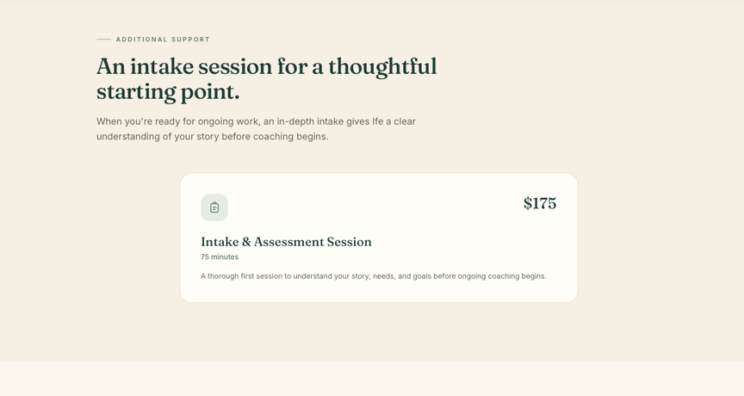
- Add Picture here
https://drive.google.com/file/d/1e1xS8qDBuy1fuYvtF6a1W_ZoZMHeIZhQ/view?usp=share_link

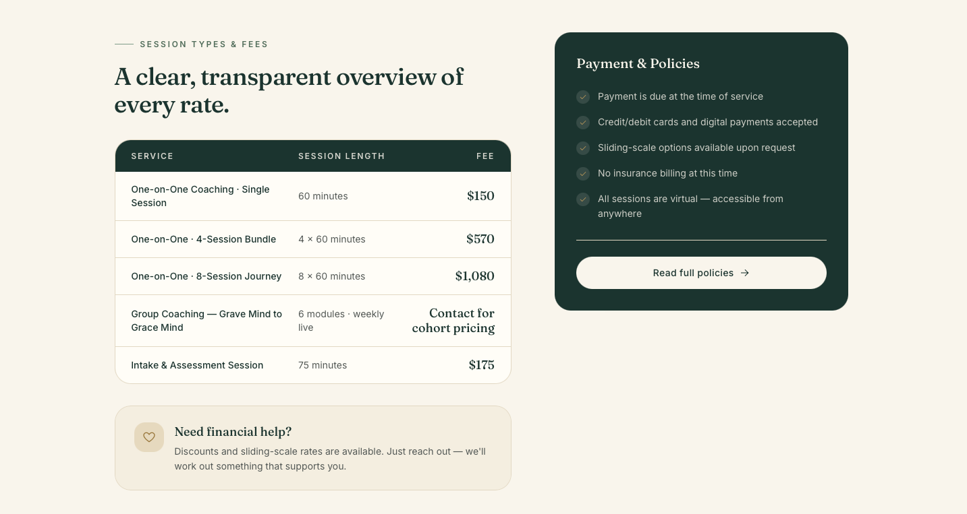

- Add picture - https://drive.google.com/file/d/1VPLR9POLQ9EjucWVvhgVgCB0aLO-VIcK/view?usp=share_link 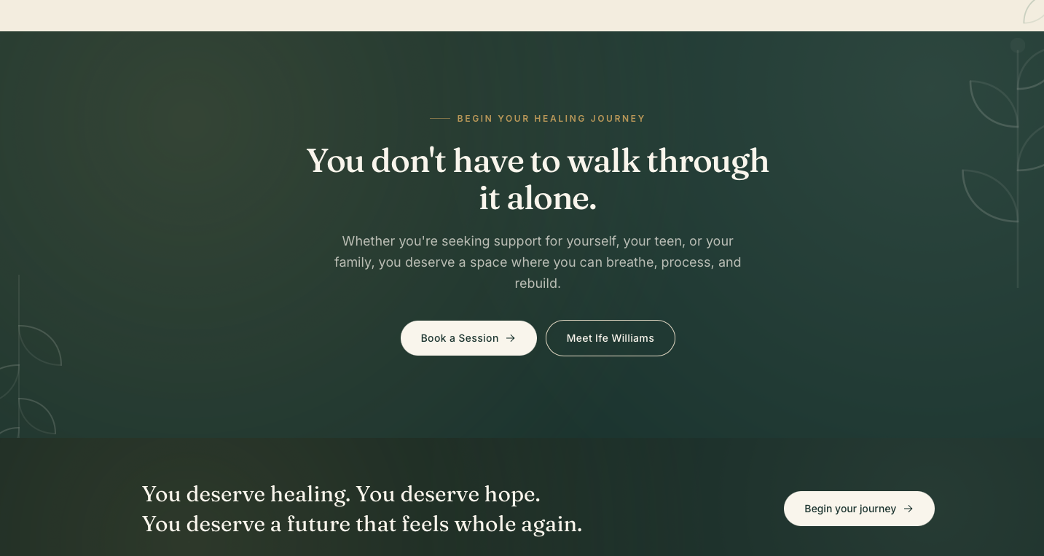

SPEAKING PAGE

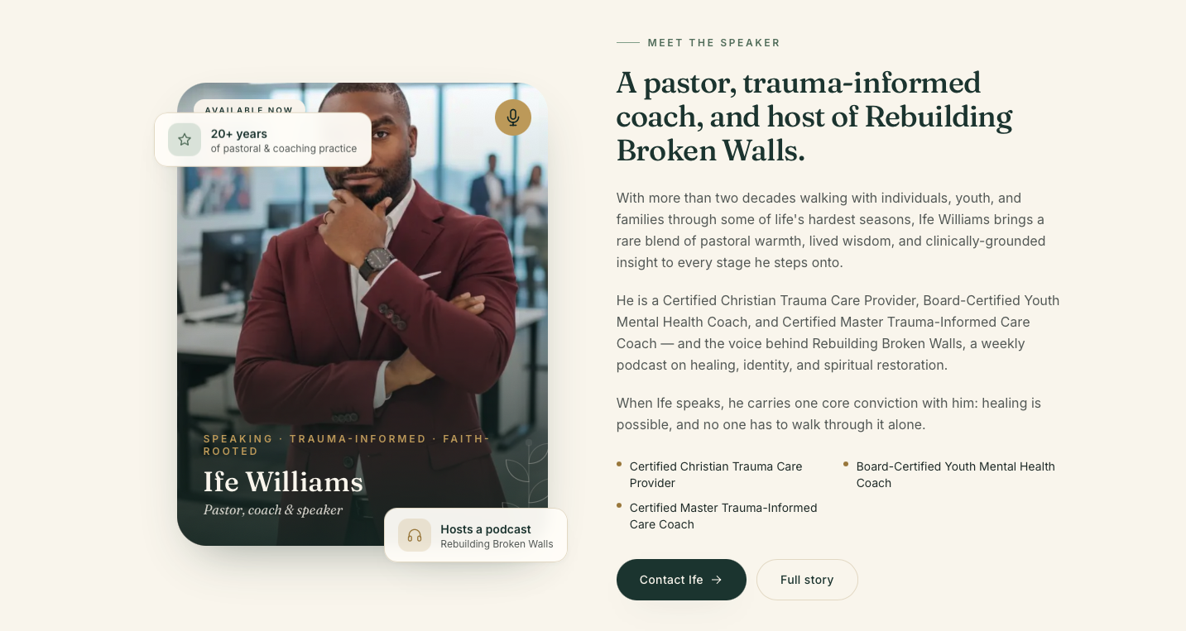
- Change Picture - https://drive.google.com/file/d/1SZLXoh7q5oJAw8eZa-MvzosQ9cKUdV5K/view?usp=share_link
- Add picture https://drive.google.com/file/d/1xe63_HteMF63Ycw2PyWufY9uGA_0GHDW/view?usp=share_link
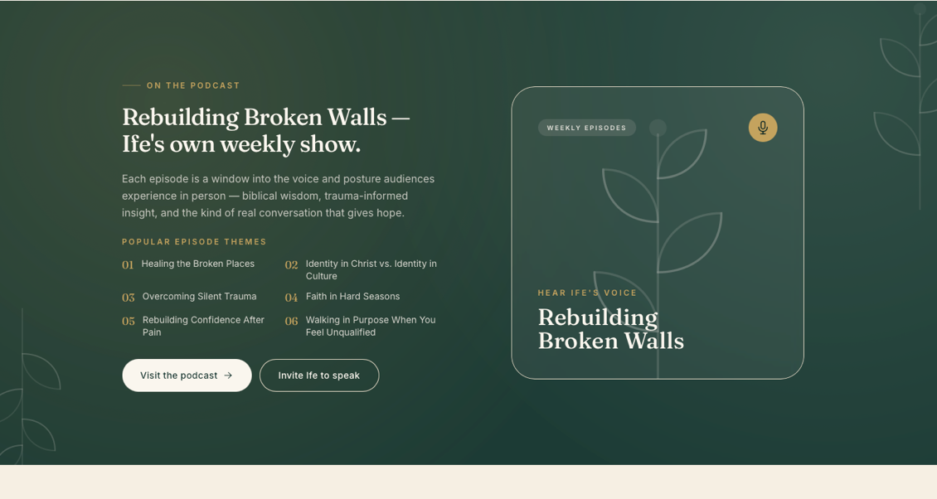

PODCAST

8. Add picture https://drive.google.com/file/d/1Gi4-5Lmz79rlaeU3qWfir3FvLYVuRy-9/view?usp=share_link
